**ANTON POŽENEL**

PORTFOLIO

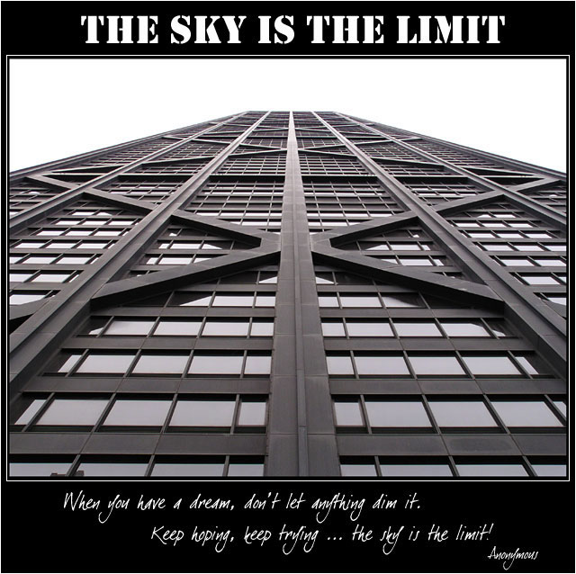

TABEL OF CONTENT

COMPANY PROFILE 3

JOB DESCRIPTION 4

THE INTERNSHIP 5

NOVOTEL 5

MY TASK 6

WHAT DID I LEARN 7

CULTURAL DIFFERENCES 8

RESPECT 8

WORKING FOR THE BOSS 9

TEAMWORK 10

# COMPANY PROFILE

**ACCOR group is the world’s leading hotel manager**and market leader in Europe,**Accor operates in 90 countries with 145,000 employees.** They provide an extensive offer include more than 15 complementary brands—from luxury to economy—that are recognized and appreciated around the world for their service quality: Sofitel, Pullman, MGallery, Novotel, Suite Novotel, Mercure, ibis, all seasons, Etap hotel, hotelF1, Motel6, as well as Thalassa sea & spa and other strategically related businesses, Lenôtre and CWL. They are present in 90 countries, with 4,100 hotels and nearly 500,000 rooms,

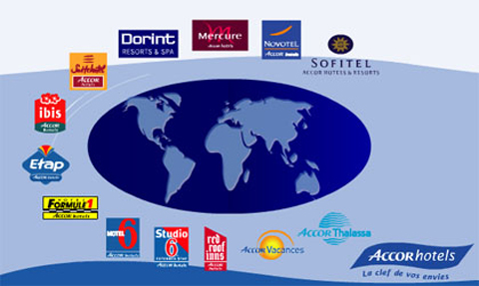

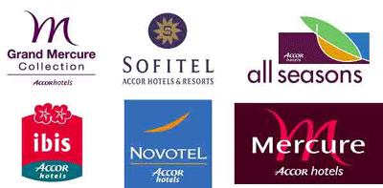

# JOB DESCRIPTION

My position in the company at beginning was helping organizing events like weddings, VIP parties, first birthday parties and parties for 70th birthday. After few weeks the general manager of our Hotel gave me a project to do and I was working on the project for the second half of my internship. The main purpose of my project was trying to figure out how to attract more students to the terrace and the bar in our hotel.

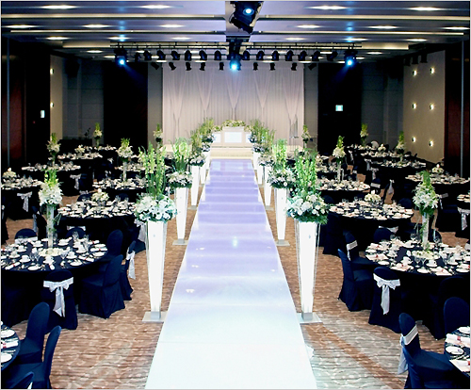

This is one of the wedding halls that we used for holding wedding ceremonies

# THE INTERNSHIP

## NOVOTEL

During my study abroad in South Korea I also did an Internship in Novotel Hotel. Novotel in Daegu is ranked as a 5 star hotel by Korean standards so obviously everything had to be on a certain level in order to achieve that standards. The restaurant and the banquet were excellent also the service that the guests receive by the staff and the rooms were very well equipped and designed in such a manner that the guests felt very good during their stay in the hotel.

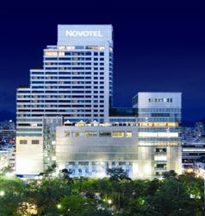

SURVEY

## MY TASK

The only thing that wasn’t on the same level as the other things in the hotel was the bar and the terrace which were located on the 8 floor of our hotel so that the guests had a nice view of the city. Because of that the general manager decided that the terrace has to be renovated and that a new strategy has to be developed. And I was also a part of that project more exactly I was handed a task by my general manager, to figure out how to attract more students to our hotel because nowadays students have bigger buying power than ever and the plan was to take the advantage of that. This was a first time for me to work alone on a project so I felt both responsibility and pressure to do a good job and with that to show my boss that his trust in giving me this project was not a mistake. So I decided to do my project in 4 steps:

ANALYSIS

 

NEW IDEAS RESULTS

 

RESULTS

## WHAT DID I LEARN

During my work on this project I learned how it is when you have to work alone on a project and how valuable the team work is. Also I felt for the first time how it is when you have to work under pressure and when you know that people are expecting something from you and you have to do your best to match those expectations. It was a valuable experience and I feel that the next when I will have to work on a project I will be able to do it faster and better.



# CULTURAL DIFFERENCES

## RESPECT

Working in Asian culture is a very different experience than working in Slovenia and in Europe. I was lucky enough to get an opportunity to do my internship during my study in Korea. The thing that I think was the most different for me was the respect that is shown among coworkers. It doesn’t matter if you’re a normal labor worker or the manager you will be almost always shown respect from your coworkers. It doesn’t mean that everyone will call you sir but a small bow is a good enough sign of their respect.

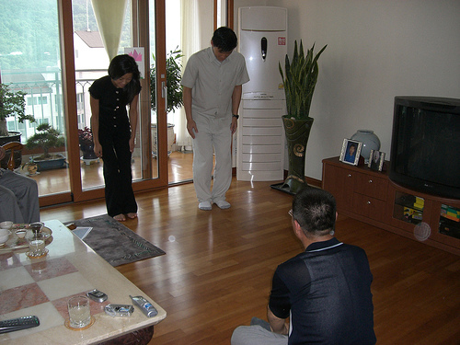

## WORKING FOR THE BOSS

However, the person that you have to respect the most when you work in a Korean environment is your boss and this is also a very big difference between Korea and Europe. If I put it in a very simple sentence, the situation is actually much more complicated, everyone works for their boss and not so much for the company. They rather see their boss happy than the stock going up for a couple of points. And in order to keep their boss happy they are prepared to put a lot of extra hours in to it and also you can expect they will work hard and almost never complain directly. They will complain among their fellow coworkers who are equal with them or with those who are lower than them but very rarely they will complain to their superiors.



## TEAMWORK

And it’s not only the respect they show but they also like teamwork. The experience that I had was that they would like to do their task as soon as possible and to do that they support team work. And I don’t mean team work only on big projects but also on small things like for example you have two boxes in your hands and you have to carry them to another room. It’s almost certain that someone from your coworkers will help you with the boxes as for Europe I can’t say that would always be the case. I must say I learned from this experience how important it is to show respect to people around you and how important team work is because it makes you feel good when you know that you belong to your team and that you can thrust them.

I think I will be able to put all of my experience in to practice next time when I will work in a company and I am sure they will be a valuable asset for my career.

